**#Aasma file**

Functional View of System

**\*Ordering catering item**

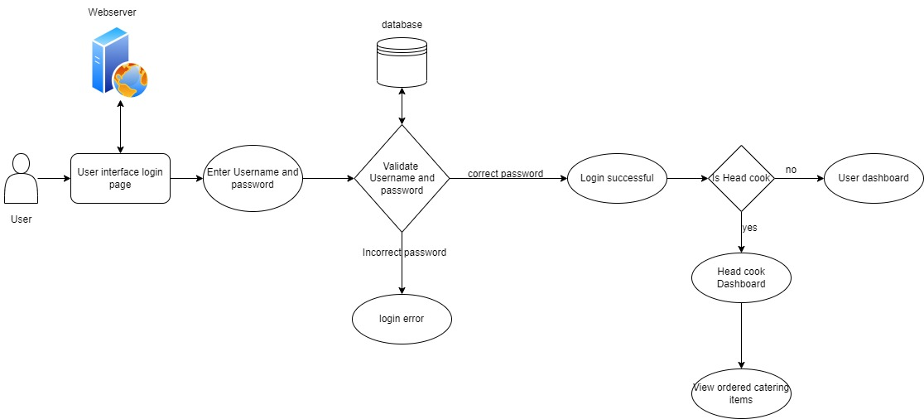

**\*Booking beauty salon**

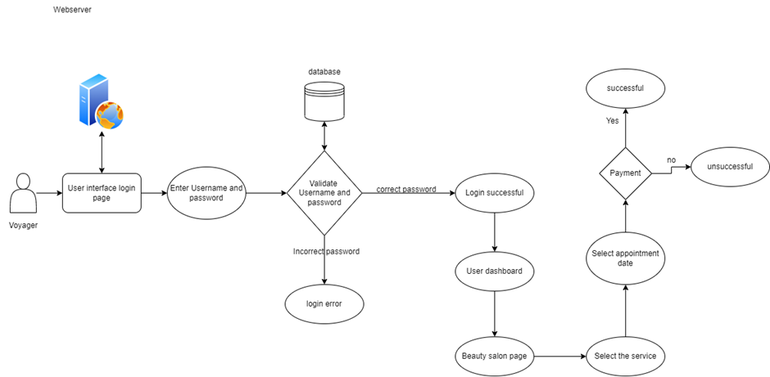

\***Booking fitness item**

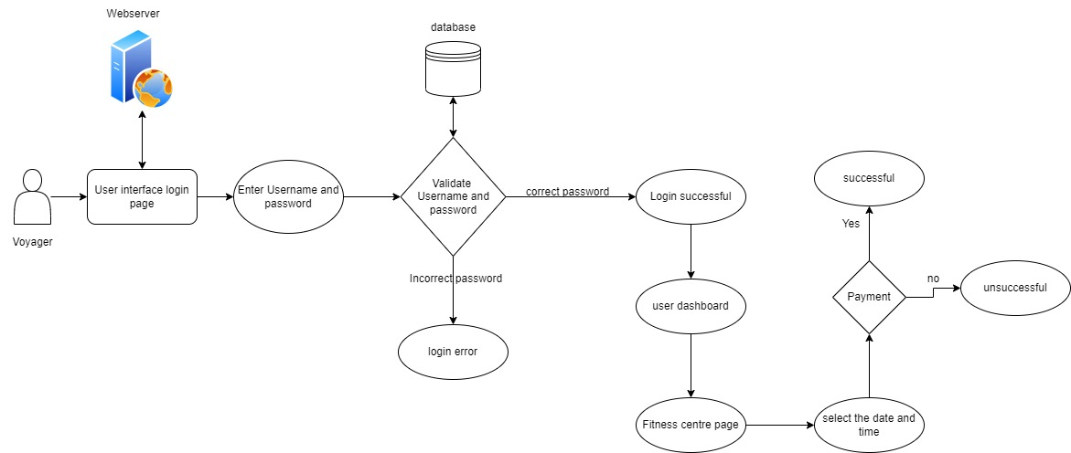

**\*Booking party hall**

